Project Overview: Dual-Motor PMSM Dynamometer

First Semester (Hardware Bring-Up)
Worked with the Simulink model: mcb_pmsm_foc_qep_dyno_f28069m (PMSM dual-motor dyno model)
Set up a dual-motor dynamometer system (drive motor + load motor)
Fixed major hardware issues:
- Incorrect three-phase motor wiring on original documentation
- Incorrect encoder pin connections on original documentation
Got the system to run correctly without hardware faults

This Semester (Control, Timing, and Data)
Fixed real-time behavior:
- Tuned SCI transmit and receive timing separately (see the Tools folder)
- Enabled “simulation pacing” in Simulink to achieve smooth, real-time operation
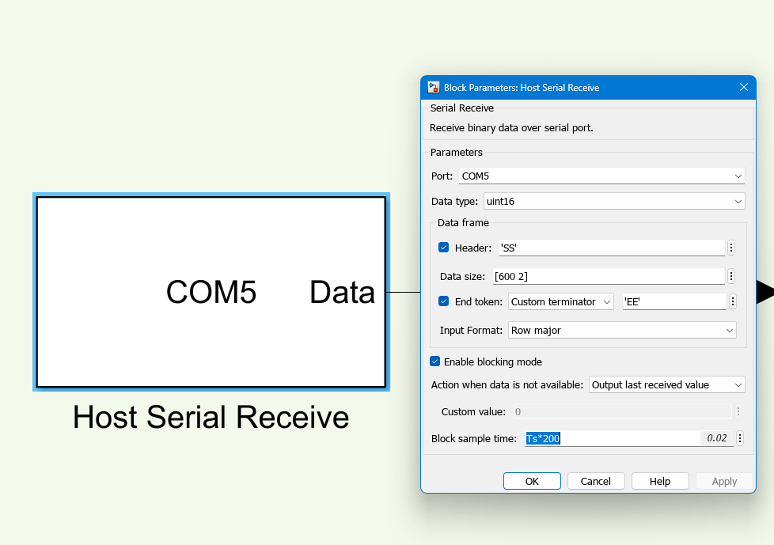
Figure 1: SCI in block sample time

Tuned PI controllers:
- Revealed proper Iq and Vq behavior for motor 1
- Stabilized performance during sweeps
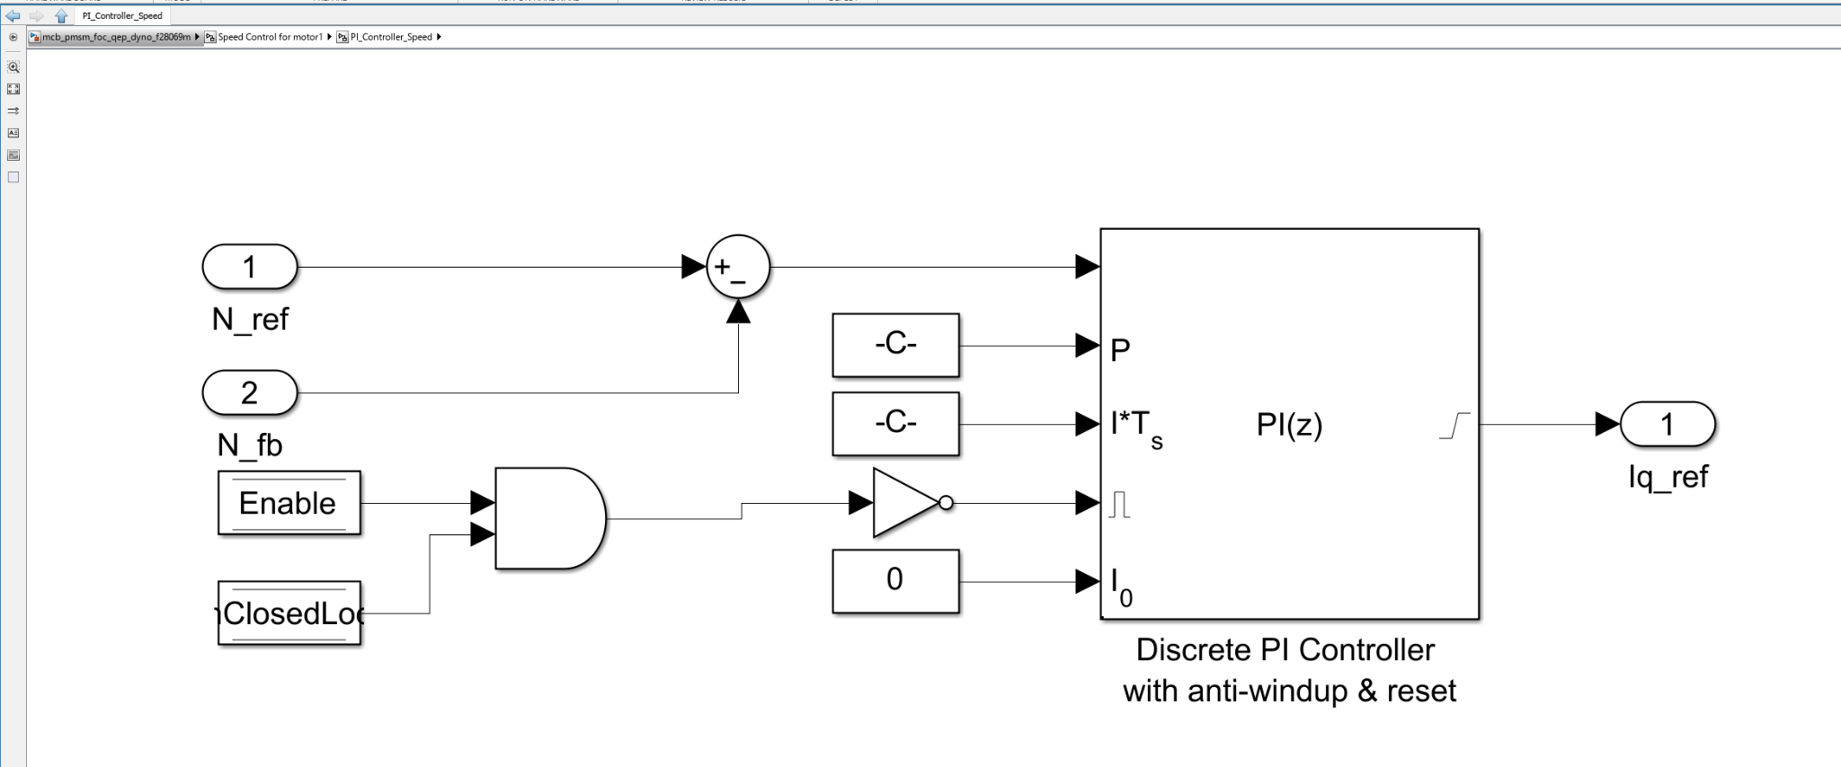
Figure 2: PI Controller
Built a repeatable test process (see software & Lab 1)
Created a MATLAB script to combine and extensively clean data (see Lab 1)
Generated Motor 1 efficiency maps from real test runs (see Lab 1)

Current Status
System runs smoothly in real time, throttles with excess data
Hardware is fully corrected
Control signals for motor 1 (Iq, Vq) behave correctly
Producing clean, usable efficiency results; now developing EPA drive cycle lab

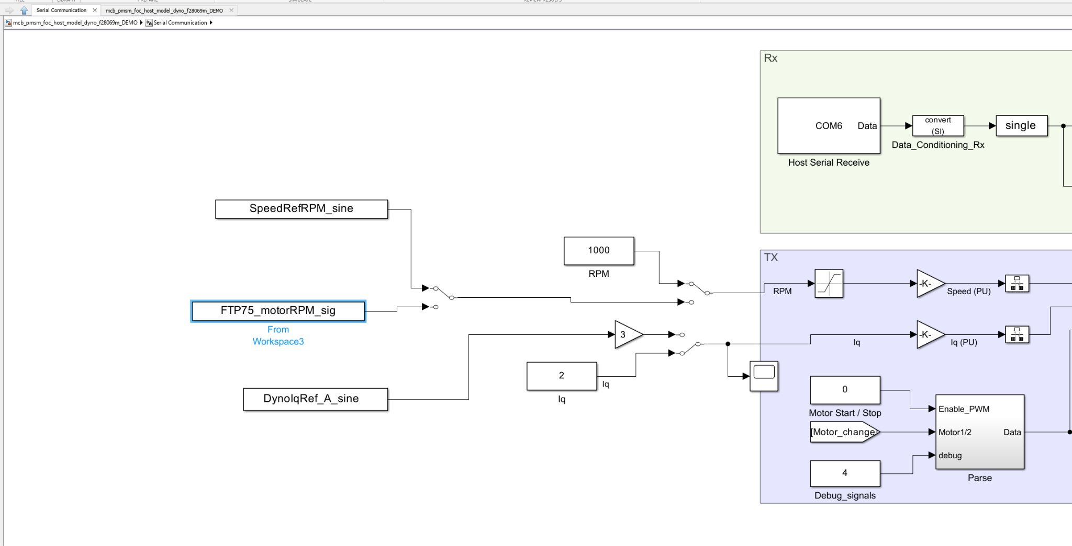
Figure 3: FTP-75 pathway on host model

Summary
First semester: fixed hardware so the dyno could run
This semester: fixed timing (SCI), tuned control loops, analyzed/cleaned data for real results to develop a motor efficiency map;
Summer: integrating EPA drivecycle onto platform; switching to CAN bus comms; enabling all debug signals over CAN; writing final software package

